Nguyễn Duy Hiếu – D15CNPM2

**SignUp Screen**

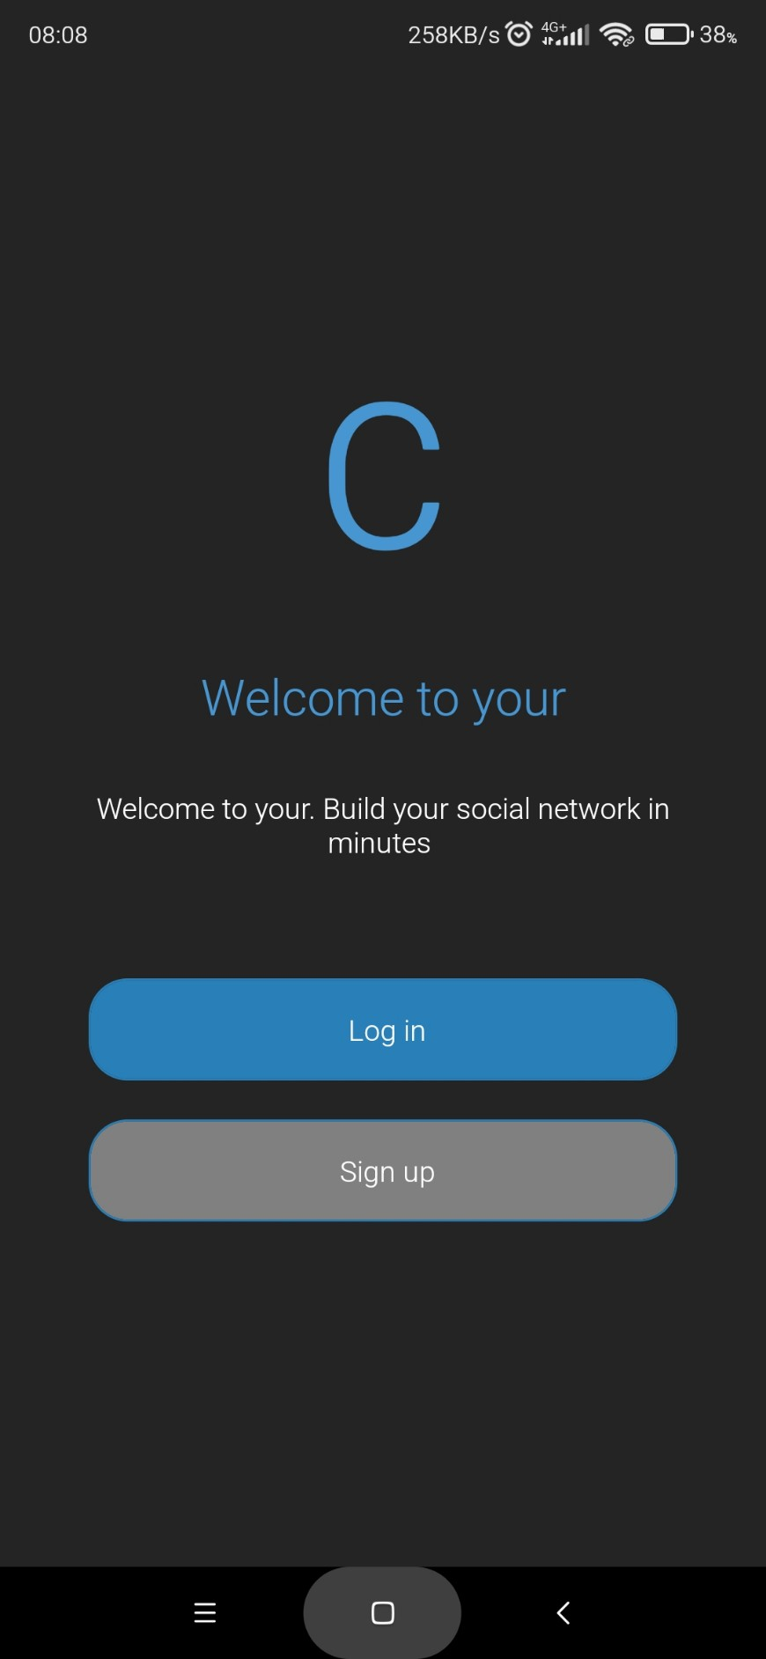

**CreateAcount Sceen**

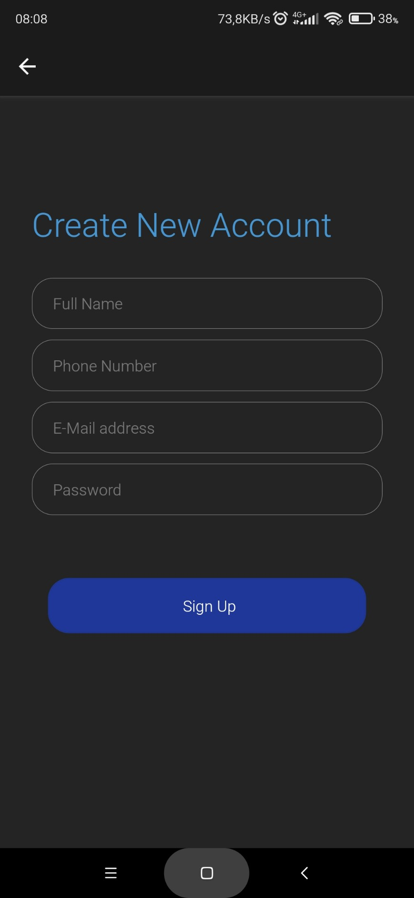

**SignIn Sceen**

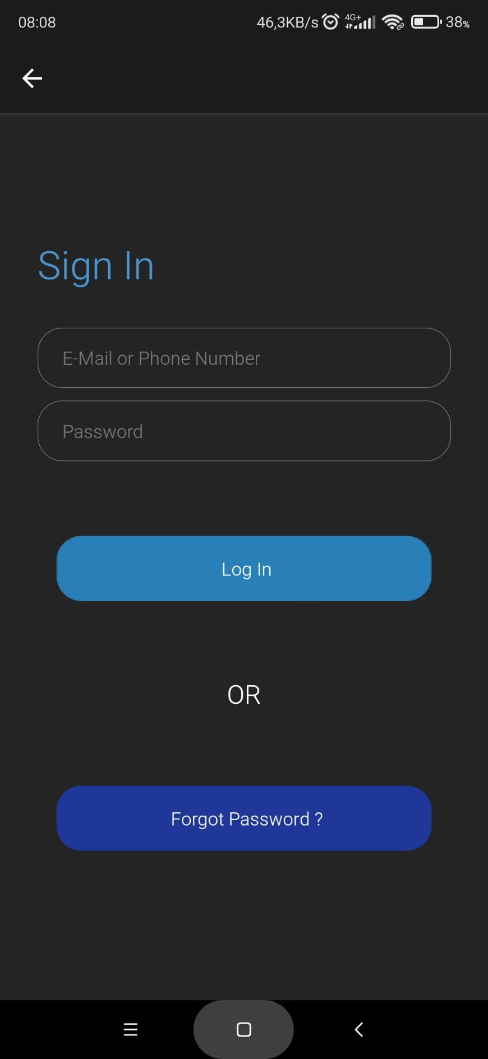

**Forgot Password Screen**

